**Design Thinking Project Workbook**

**Don't find customers for your product but find products for your customers**

**1. Team**

**Team Name:tracker**

**Team Logo (if any):**

**Team Members:**

1. [Tatva Talasila,documentation,execution]
2. [Harsha Vardhan Reddy,Researcher ]
3. [B.varshitha, coder,tester]
4. [M.jaykar, Analyst]

**2. Problem/Opportunity Domain**

**Domain of Interest: Workout and Fitness Tracker**

**Description of the Domain: The fitness industry has seen a surge in digital tools aimed at helping individuals track their workouts, monitor progress, and maintain motivation. However, there are still challenges in creating an all-in-one workout and fitness tracker that seamlessly integrates exercise planning, tracking, and personalized insights.**

**Why did you choose this domain?: With a growing focus on health and fitness, many individuals are seeking efficient ways to track their workouts, measure progress, and stay motivated. We aim to provide a solution that combines these elements into one user-friendly platform, making it easier for users to achieve their fitness goals.**

**3. Problem/Opportunity Statement**

**Problem Statement: Many individuals struggle to consistently track their workouts and monitor their fitness progress due to a lack of effective and integrated workout and fitness tracking solutions.**

**Problem Description: Despite the availability of numerous fitness apps, users often find it difficult to log their workouts, track performance, and monitor improvements effectively. They need a comprehensive platform that combines workout planning, tracking, and personalized insights.**

**Context: The problem is most apparent when users try to follow a consistent workout routine but find it cumbersome to manually log exercises, switch between multiple apps, or track progress over time.**

**Alternatives: Users often use separate workout logs, physical journals, or multiple fitness apps to track different activities, leading to a fragmented and confusing experience.**

**Customers: Fitness enthusiasts, athletes, gym-goers, and individuals aiming to improve their health who want an integrated, easy-to-use way to track their workouts and see their progress.**

**Emotional Impact: Users may feel frustrated, unmotivated, or overwhelmed when they struggle to track their workouts consistently or when their efforts do not seem to translate into visible progress.**

**Quantifiable Impact: Ineffective tracking can lead to stagnation, decreased motivation, and inconsistency in following workout routines, ultimately hindering fitness progress.**

**Alternative Shortcomings: Current solutions often focus solely on workout tracking or health metrics, without effectively integrating both. Managing multiple apps can be time-consuming and inefficient.**

**4. Stakeholders**

1. **Who are the key stakeholders involved in or affected by this project?**

* Fitness Enthusiasts: Individuals who regularly work out and want to track their progress.
* Personal Trainers: Professionals who guide clients through workout routines and track their clients' fitness journey.
* Gym Owners: Manage facilities that offer workout services and equipment, and might use the tracker to enhance member experiences.
* Health and Wellness Coaches: Professionals who monitor clients' overall health, including fitness, diet, and mental well-being.
* Sports Teams and Athletic Coaches: Track performance metrics for athletes and teams.
* App Developers and Designers: Responsible for building and maintaining the fitness tracker application.

1. **What roles do the stakeholders play in the success of the innovation?**

* **Fitness Enthusiasts: Primary users who provide feedback on features, usability, and effectiveness.**
* **Personal Trainers: Secondary users who help integrate the app into workout routines and can recommend it to clients.**
* **Gym Owners: Can partner to offer the app as a part of their membership packages, driving more user adoption.**
* **Health and Wellness Coaches: Can use the app to track and recommend fitness plans, expanding the tracker’s reach.**
* **Sports Teams and Athletic Coaches: Provide feedback on performance-tracking features and help promote the app's use in professional settings.**
* **App Developers and Designers: Ensure the app is user-friendly, robust, and meets the needs of all user types.**
* **Investors and Business Partners: Provide resources and strategic guidance to scale and market the product.?**

1. **How much influence does each stakeholder have on the outcome of the project?**

* **Fitness Enthusiasts: Interested in an easy-to-use tracker that provides accurate and comprehensive workout insights. Concerned about data privacy and app usability.**
* **Personal Trainers: Need reliable data tracking to monitor client progress and customize workout plans. Concerned about app integration with existing systems.**
* **Gym Owners: Interested in tools that enhance member engagement and retention. Concerned about costs and ease of adoption.**
* **Health and Wellness Coaches: Need a comprehensive view of clients' fitness journeys. Concerned about integration with other health-monitoring tools.**
* **Sports Teams and Athletic Coaches: Interested in advanced performance metrics. Concerned about the accuracy of data tracking.**
* **App Developers and Designers: Focused on creating a robust and user-friendly app. Concerned about technical challenges and meeting user expectations.**
* **Investors and Business Partners: Interested in product viability and market potential. Concerned about return on investment (ROI) and scalability.**

1. **What is the level of engagement or support expected from each stakeholder?**

* **Fitness Enthusiasts: High influence as they are the end-users. Their feedback directly impacts the app's features and improvements.**
* **Personal Trainers: Medium influence since their professional endorsement can drive user adoption.**
* **Gym Owners: Medium to high influence, especially if they adopt the tracker for their clients.**
* **Health and Wellness Coaches: Medium influence; their use of the tracker can promote it within health and fitness circles.**
* **Sports Teams and Athletic Coaches: Medium influence, particularly for advanced features related to sports performance.**
* **App Developers and Designers: High influence as they build and optimize the app.**
* **Investors and Business Partners: High influence due to their role in funding and strategic decisions.**

1. **Are there any conflicts of interest between stakeholders? If so, how can they be addressed?**

* **Fitness Enthusiasts: Active engagement through regular use and feedback.**
* **Personal Trainers: Moderate engagement; using the tracker with clients and providing insights.**
* **Gym Owners: Support through partnerships, promotions, and possible integration into their services.**
* **Health and Wellness Coaches: Moderate engagement by incorporating the app into client wellness plans.**
* **Sports Teams and Athletic Coaches: Regular engagement, especially with performance-tracking features.**
* **App Developers and Designers: Continuous support in terms of app updates, feature additions, and troubleshooting.**
* **Investors and Business Partners: Support through funding, networking, and strategic direction.v**

1. **How will you communicate and collaborate with stakeholders throughout the project?**

* **Conflict: Personal trainers and gym owners might have differing priorities regarding app usage (e.g., trainers might want features that gym owners do not see as necessary).**
* **Resolution: Establish clear communication and provide customization options that allow different stakeholders to tailor the app to their needs.**

1. **What potential risks do stakeholders bring to the project, and how can these be mitigated?**

* Fitness Enthusiasts: User surveys, beta testing programs, and regular updates on new features.
* Personal Trainers and Coaches: Regular feedback sessions, focus groups, and dedicated support channels.
* Gym Owners: Business meetings, demonstrations, and integration workshops.
* App Developers and Designers: Agile development cycles with regular meetings and collaborative platforms (e.g., Jira, Slack).
* Investors and Business Partners: Quarterly progress reports, strategy meetings, and presentations.

**8.What potential risks do stakeholders bring to the project, and how can these be mitigated?**

* Fitness Enthusiasts: Risk of disengagement if the app does not meet their needs. Mitigation: Regular feedback loops and user-driven feature updates.
* Personal Trainers: Resistance to adopting new technology. Mitigation: Provide training and show the benefits of using the tracker.
* Gym Owners: Concern about cost and integration. Mitigation: Offer flexible pricing models and seamless integration options.
* App Developers: Technical challenges. Mitigation: Ensure a robust development process and thorough testing phases.
* Investors: Risk of not seeing ROI. Mitigation: Clear business plans, market analysis, and regular updates on progress.

**5. Power Interest Matrix of Stakeholders**

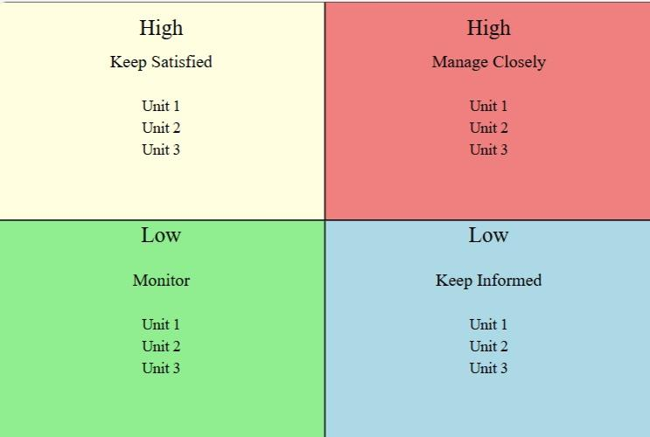

|  |  |  |  |
| --- | --- | --- | --- |
| * Power | * Interest | * Stakeholders | * Management Strategy |
| * High Power, High Interest | * Key Players | * - Investors and Business Partners | * Engage closely and regularly. Involve them in decision-making and keep them informed. |
| * High Power, Low Interest | * Keep Satisfied | * Gym Owners | * Keep them satisfied with regular updates. Address concerns without overwhelming them with details. |
| * Low Power, High Interest | * Keep Informed | * Fitness Enthusiasts * - Personal Trainers * - Health and Wellness Coaches * - Sports Teams and Athletic Coaches | * Regular updates and feedback sessions. Engage them with surveys and beta programs. |
| * Low Power, Low Interest | * Monitor | * Potential App Users Not Yet Engaged | * Monitor and keep under observation. Engage if their interest increases. |

**7.Empathetic Interviews**

|  |  |  |
| --- | --- | --- |
| **I need to know**  **(thoughts, feelings, actions)** | **Questions I will ask**  **(open questions)** | **Insights I hope to gain** |
| Thoughts | ·What do you think about current fitness tracking apps? | What users perceive as strengths and weaknesses in existing solutions. |
|  | How do you believe a fitness tracker can help you achieve your goals? | User expectations and desired features. |
|  | What features do you think are missing in existing fitness trackers? | User beliefs about the effectiveness of fitness tracking. |
| Feelings | How do you feel when you use fitness tracking apps? | Emotional responses to using fitness trackers. |
|  | What emotions do you experience when you see your progress over time? | Feelings about progress tracking and motivation. |
|  | How motivated do you feel to use a fitness tracker regularly? | Emotional barriers or enablers to regular use. |
| actions | How often do you log your workouts? | Frequency and consistency of logging workouts. |
|  | What steps do you take to track your fitness progress? | Methods users currently employ to track fitness. |
|  | How do you integrate fitness tracking into your daily routine? | Daily integration of fitness tracking practices. |

**SKILLED INTERVIEW REPORT**

|  |  |  |
| --- | --- | --- |
| **User/Interviewee** | **Questions Asked** | **Insights gained (NOT THEIR ANSWERS)** |
| Abhishek Verma,  Student | What do you think about current fitness tracking apps? | Thoughts: Users believe a better tracker can provide clearer progress insights. |
| Srinivasan P., Parent | How do you feel when you use fitness tracking apps? | Feelings: Users feel a mix of pride and frustration with their progress tracking. |
|  | How often do you log your workouts? | Actions: Users rely on manual tracking and often forget to log workouts. |

**Key Insights Gained:**

· Many users find current fitness trackers lacking in comprehensive and easy-to-use features.

· Emotional responses to fitness tracking can greatly affect user motivation and consistency.

· Simplifying the tracking process and providing clear progress insights can enhance user engagement.

**Empathy Map**

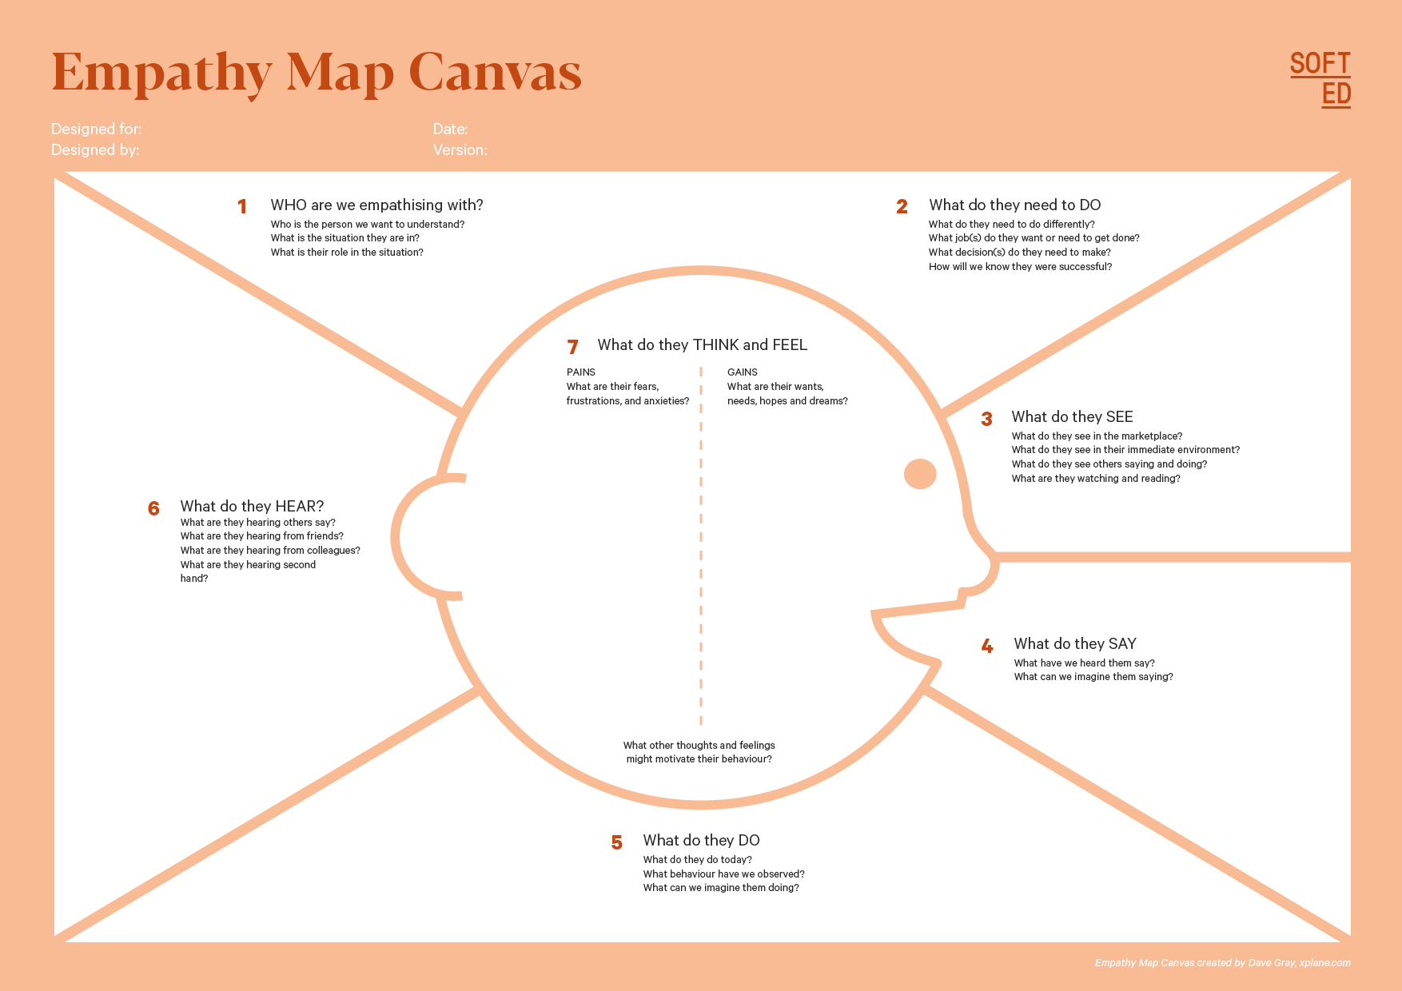

Your Answer:

Your Answer:

Who is your Customer Segment:

Idea/Innovation Title:

Designed By:

Date of Submission:

Your Answer:

Your Answer:

Your Answer:

Your Answer:

Your Answer:

Your Answer:

Your Answer:

1. **Empathy Map**
2. **Who is your Customer?**

**Description:**

·**Profile**: Fitness Enthusiasts aged 18-40, including professionals and students.

· **Goals and Needs**: Personalized workout plans, progress tracking, and motivation enhancement.

· **Context**: Interacting with the solution during workouts, at home, and on-the-go.

1. **Who are we empathizing with?**

· **Characteristics**: Motivated, health-conscious, technology-savvy individuals.

· **Goals and Challenges**: Achieving fitness goals efficiently, overcoming workout plateaus, and maintaining motivation.

·**Broader Situation**: Balancing fitness with busy professional or academic schedules.

1. **What do they need to DO?**

· **Tasks/Actions**: Log workouts, track calorie intake, set and achieve fitness goals.

· **Decisions**: Choose workout plans, monitor progress, adjust routines.

· **Success/Failure**: Success is defined by consistent progress and goal achievement, failure by lack of progress and motivation.

1. **What do they SEE?**

· **Environment**: Fitness apps, workout equipment, gym environments, social media fitness trends.

· **Trends/Competitors**: Noticing competitor fitness apps and health trends.

· **Influence**: Visual elements that enhance or diminish motivation, such as progress graphs and community support.

1. **What do they SAY?**

· **Public Expression**: Share their fitness journey on social media, provide feedback on apps, discuss workout challenges with peers.

· **Goals/Frustrations**: Express desire for better progress tracking and integrated solutions.

· **Feedback**: Comments during customer interviews and on feedback platforms.

1. **What do they DO?**

· **Actions**: Regularly log workouts, track calories, follow workout plans.

· **Habits/Routines**: Consistent workout schedules, using fitness apps daily.

· **Problem-solving**: Seek new workout plans, adjust diets, and use multiple apps to track different fitness aspects.

1. **What do they HEAR?**

· **External Sources**: Fitness coaches, peers, social media influencers, industry trends.

· **Media/Channels**: Fitness blogs, YouTube channels, podcasts.

· **Influencers**: Trainers, fitness experts, and community feedback guiding their behavior.

1. **What do they THINK and FEEL?**

· **Fears/Anxieties**: Fear of not achieving fitness goals, anxiety about body image and health.

· **Motivations/Desires**: Desire to be fit, healthy, and feel good about themselves.

· **Alignment**: Thoughts and feelings often align with their determination to follow routines and achieve goals.

1. **Pains and Gains**

· **Pain Points**: Inconsistent tracking, lack of integrated solutions, motivation dips.

·**Easier Life**: Simplified tracking, comprehensive insights, and motivational features.

·**Benefits Hoped to Achieve**: Efficient progress tracking, personalized workout recommendations, enhanced motivation.

**8. Persona of Stakeholders**

**Stakeholder Name:**

**Demographics:**

· **Age**: 25

· **Gender**: Female

· **Income**: $40,000 annually

· **Location**: Urban area, New York City

**Goals:** · Achieve a consistent workout routine

· Track fitness progress effectively

· Stay motivated and engaged with fitness activities

**Challenges:**· Difficulty in maintaining a workout log

· Inconsistency in tracking progress due to busy schedule

· Lack of integrated solutions for comprehensive tracking

**Aspiration:**

· Dream of running a marathon and staying in peak physical condition

· Long-term health and fitness improvement

· Achieve a balanced lifestyle that incorporates regular exercise

**Needs:** · A user-friendly app that integrates all aspects of fitness tracking

· Personalized workout plans that fit into a busy schedule

· Motivation tools and progress tracking features

**Pain Points:** · Frustration with switching between multiple apps for different tracking needs

· Overwhelmed by manual logging of workouts

· Difficulty in visualizing progress over time

**Storytelling:**

Meet Emily, a 25-year-old professional living in the bustling city of New York. Between her demanding job and social life, Emily is passionate about staying fit and healthy. She dreams of running a marathon one day but often struggles to maintain a consistent workout routine.

Emily uses several fitness apps and a physical journal to track her workouts, but the fragmented approach leaves her frustrated. She finds it challenging to log her exercises daily and often loses track of her progress.

One evening, Emily stumbles upon the Fitness and Workout Tracker app. It promises to integrate all her fitness tracking needs into one user-friendly platform. Intrigued, she downloads the app and sets up her profile.

Within days, Emily notices a change. The app provides personalized workout plans tailored to her goals and schedule. It logs her workouts effortlessly and tracks her progress with visual graphs. The motivational features keep her engaged, and for the first time in months, Emily feels in control of her fitness journey.

The app's seamless integration into her daily routine gives Emily the consistency she craves. She watches as her progress charts improve, and her dream of running a marathon feels more achievable. Emily's fitness journey is transformed, thanks to the Fitness and Workout Tracker.

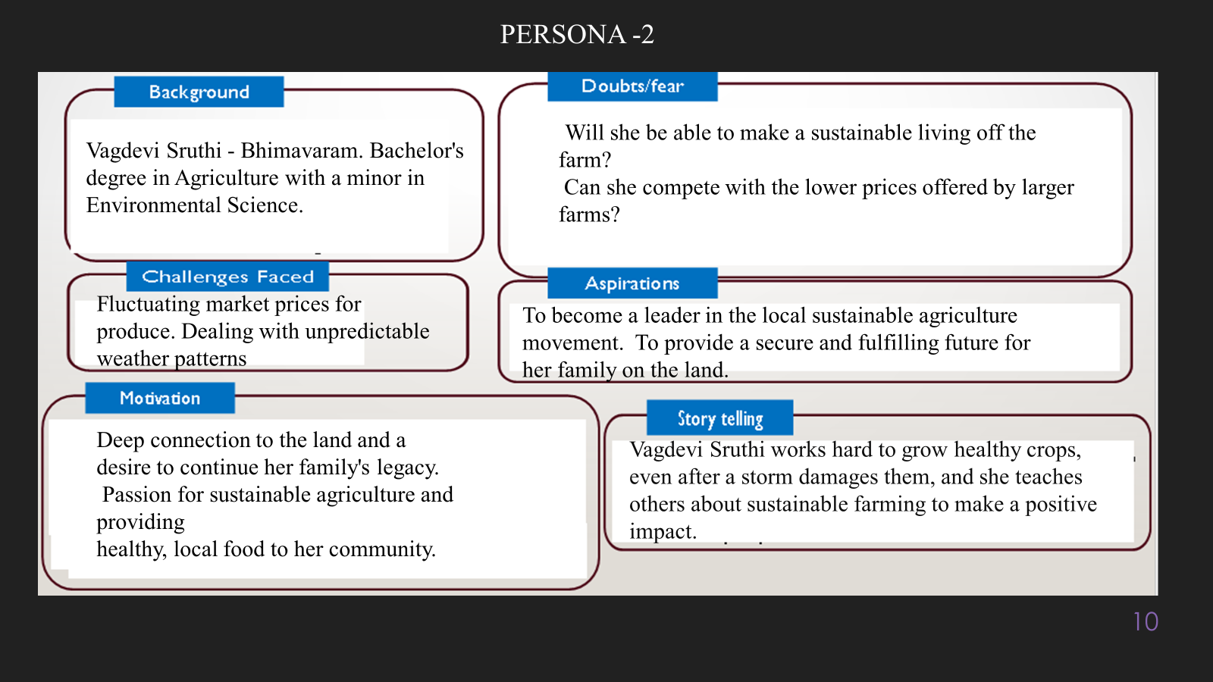

**10. Look for Common Themes, Behaviors, Needs, and Pain Points among the Users**

#### **common Themes:**

**Integration of Features**: Users frequently mention the need for a comprehensive platform that integrates workout planning, progress tracking, and personalized insights.

**User-Friendliness**: The ease of use and intuitive design are recurring themes, emphasizing the need for a simple and accessible interface.

**Motivation and Engagement**: Many users express a desire for features that enhance motivation, such as visual progress graphs and goal-setting tools.

**Customization**: Personalized workout plans tailored to individual goals and schedules are a common expectation.

#### **Common Behaviors:**

**Inconsistent Logging**: Users often start tracking their workouts but struggle to maintain consistency over time.

**Multi-App Usage**: There is a tendency to use multiple apps and tools to fulfill various fitness tracking needs, leading to fragmented data.

**Feedback Seeking**: Users actively seek feedback on their progress and look for validation through visual representations and progress reports.

**Social Sharing**: Many users share their fitness journey on social media and value community support.

#### **Common Needs:**

**Comprehensive Tracking**: A unified solution that combines all aspects of fitness tracking, including workouts, nutrition, and progress.

**Personalization**: Customized workout plans and progress insights that cater to individual fitness goals and preferences.

**Motivational Tools**: Features that keep users engaged and motivated, such as reminders, goal-setting, and achievement badges.

**Data Visualization**: Clear and easy-to-understand visual representations of progress and performance metrics.

#### **Common Pain Points:**

**Fragmented Tracking**: The need to use multiple apps and tools leads to a disjointed tracking experience and data fragmentation.

**Complex Interfaces**: Difficulty navigating complicated interfaces and logging workouts manually.

**Lack of Motivation**: Users often feel demotivated due to the absence of engaging and motivational features in existing solutions.

**Inaccurate Tracking**: Concerns about the accuracy of data tracking, particularly in relation to performance metrics and progress reports

**12. Define Needs and Insights of Your Users**

### **User Needs and Insights**

**User Needs:**

**Functional Needs:**

**Comprehensive Tracking**: Users require an all-in-one platform that seamlessly tracks workouts, nutrition, and overall progress.

**User-Friendly Interface**: A simple and intuitive interface that makes it easy to log and monitor fitness activities.

**Customization**: Personalized workout plans and recommendations that cater to individual goals and schedules.

**Integration**: Ability to sync with various fitness devices and apps for a unified experience.

**Emotional Needs:**

**Motivation**: Features that encourage users to stay motivated and committed, such as reminders, progress badges, and goal-setting tools.

**Validation**: Visual representations of progress, such as charts and graphs, that provide positive reinforcement.

**Support**: Community features that offer support and a sense of belonging, such as social sharing and fitness challenges.

**Societal Needs:**

**Community Engagement**: Social features that allow users to share their fitness journey, connect with others, and participate in group challenges.

**Accessibility**: Ensuring the app is accessible to a wide range of users, including those with disabilities.

**User Insights:**

**Behavioral Insights:**

Users often struggle with consistency due to fragmented tracking tools and busy schedules.

There is a tendency to use multiple apps for different aspects of fitness tracking, leading to a disjointed experience.

Users actively seek feedback and validation through visual progress tracking and community support.

**Motivational Insights:**

Users are driven by the desire to achieve their fitness goals efficiently and effectively.

Motivation fluctuates based on the ease of use and visibility of progress.

Emotional responses, such as pride in achievements and frustration with setbacks, significantly influence user engagement.

**Pain Points:**

Inconsistent logging and the cumbersome nature of manual tracking hinder user progress.

The lack of integration across various fitness tracking tools creates a fragmented experience.

Users feel demotivated without engaging features that provide feedback and encourage progress.

**13. POV Statements**

**POV Statements:**

|  |  |  |  |
| --- | --- | --- | --- |
| **PoV Statements**  **(At least ten)** | **Role-based or Situation-Based** | **Benefit, Way to Benefit,**  **Job TBD,**  **Need (more/less)** | **PoV Questions**  **(At least one per statement)** |
| Fitness Enthusiast needs a way to track workouts seamlessly because switching between multiple apps is cumbersome. | Fitness Enthusiast | · Integrated workout tracking | How might we create an all-in-one fitness platform that integrates workout tracking? |
| Personal Trainer needs a way to monitor client progress efficiently because managing multiple clients' data is overwhelming. | Personal Trainer | · Simplified client progress tracking  · · · | How might we design a feature that simplifies client progress tracking? |
| **Gym Owner needs a way to enhance member engagement because retaining members is challenging.** | Gym Owner | Increased member engagement | How might we introduce features to keep gym members motivated and engaged? |
| Health Coach needs a way to get a comprehensive view of client health because fragmented data makes holistic tracking difficult. | Health Coach | Integrated health data tracking | How might we design a system that integrates fitness, diet, and mental well-being data? |
| Athlete needs accurate performance metrics because training effectiveness relies on precise data. | Athlete | Accurate performance tracking | How might we ensure the accuracy of performance tracking? |
| Busy Professional needs a way to log workouts quickly because detailed logging is time-consuming. | Busy Professional | Streamlined workout logging | How might we streamline the workout logging process? |
| Student needs motivational tools to stay consistent because maintaining a workout routine is challenging with a busy schedule. | student | Enhanced motivation | How might we add features to help students stick to their fitness plans? |
| New User needs an easy onboarding process because complex setups can discourage continued use. | New user | Simplified onboarding | How might we simplify the onboarding process to retain new users? |
| Nutrition Enthusiast needs a way to track calorie intake accurately because diet plays a crucial role in fitness. | Nutrition Enthusiast | Accurate calorie tracking | How might we make calorie tracking easy and accurate? |
| Fitness Blogger needs to share progress and tips easily because influencing others is part of their role. | Fitness Blogger | Easy sharing of progress and tips | How might we create features that enable easy sharing of progress and fitness tips on social media? |

**14. Develop POV/How Might We (HMW) Questions to Transform Insights/Needs into Opportunities for Design**

Turn your user needs and insights into actionable opportunities by framing them as "How Might We" (HMW) questions. These questions will spark creative problem-solving and guide your innovation process.

on the user needs and insights identified, here are some HMW questions to spark creative problem-solving and innovation:

**User Need:** Users need a comprehensive and integrated solution for fitness tracking.

**HMW Question:** How might we create an all-in-one fitness platform that seamlessly integrates workout planning, tracking, and personalized insights?

**Insight:** Users feel demotivated without engaging and motivational features.

**HMW Question:** How might we design features that boost user motivation and engagement through visual progress tracking and goal-setting tools?

**User Need:** Users need a user-friendly interface to easily log and track workouts.

**HMW Question:** How might we develop an intuitive and simple interface that makes logging workouts quick and effortless?

**Insight:** Users struggle with inconsistent tracking due to fragmented tools.

**HMW Question:** How might we streamline fitness tracking by consolidating multiple tracking functions into a single, cohesive application?

**User Need:** Users need personalized workout plans that fit into their busy schedules.

**HMW Question:** How might we create customizable workout plans that adapt to users' individual goals and schedules, ensuring they remain consistent and motivated?

**16. Crafting a Balanced and Actionable Design Challenge**

The Design Challenge Should Neither Be Too Narrow Nor Too Broad and It Should Be an Actionable Statement with a quantifiable goal. It should be a culmination of the POV questions developed.

**Design Challenge:**

**Actionable Statement:**

**How might we create an all-in-one fitness platform that seamlessly integrates workout planning, tracking, and personalized insights, to enhance user motivation and engagement, ensure user-friendly logging, and provide customized workout plans that adapt to individual goals and schedules, with the aim of increasing user consistency in fitness tracking by 50% over the next 6 months?**

**17. Validating the Problem Statement with Stakeholders for Alignment**

Ensure your problem statement accurately represents the needs and concerns of your stakeholders and users. This involves gathering feedback from these groups to confirm that the problem is relevant and significant from their perspective. By validating early, you can refine the problem statement to better align with real-world challenges, ensuring your solution addresses the correct issues.

**Objective:** Ensure the problem statement accurately represents the needs and concerns of stakeholders and users by gathering feedback and making necessary refinements.

| **Stakeholder/User** | **Role/Title** | **Feedback on Problem Statement** | **Suggestions for Improvement** |
| --- | --- | --- | --- |
| Fitness Enthusiasts Group | Regular Users | The problem resonates as they struggle with fragmented tracking tools. | Focus on seamless integration and ease of use. |
| John Smith | Personal Trainer | The problem is relevant but needs more emphasis on client management. | Include specific features for client progress tracking. |
| Sarah Lee | Gym Owner | Resonates well; member engagement is a significant challenge. | Add features for member retention and engagement. |
| Wellness Coaches Network | Health and Wellness Coaches | The holistic tracking aspect is well-addressed. | Ensure the integration of mental well-being tracking. |
| Athletic Performance Group | Sports Coaches | Accurate performance metrics are crucial and well-covered. | Highlight the accuracy and reliability of tracking features. |
| Emily Johnson | Busy Professional | Logging workouts quickly is a major need; the problem is accurate. | Simplify the logging process even further. |
| University Fitness Club | Students | Maintaining a workout routine is challenging; problem is well-stated. | Focus on motivational tools and reminders. |
| New User Group | General Users | Easy onboarding is essential; the problem resonates. | Streamline the onboarding process and provide tutorials. |
| Nutrition Enthusiasts Forum | Diet and Nutrition Users | Accurate calorie tracking is necessary and well-addressed. | Ensure the app provides detailed nutritional insights. |
| Fitness Influencers | Bloggers and Influencers | Easy sharing of progress is a key concern; problem statement aligns. | Enhance social sharing features and integrate with social media platforms. |

**18. Ideation**

**Ideation Process:**

make in a proper formate to directly copy paste

Here is the properly formatted table for direct copy-paste:

### Ideation Process

| **Idea Number** | **Proposed Solution** | **Key Features/Benefits** | **Challenges/Concerns** |
| --- | --- | --- | --- |
| Idea 1 | Comprehensive Fitness Platform | - Seamless integration of workout planning, tracking, and insights<br>- User-friendly interface<br>- Personalized recommendations | - Development complexity<br>- High initial cost |
| Idea 2 | Gamified Motivation Tools | - Achievement badges<br>- Leaderboards<br>- Fitness challenges | - Ensuring fairness<br>- Maintaining user interest long-term |
| Idea 3 | Social Integration Features | - Social sharing<br>- Community support<br>- Group challenges | - Privacy concerns<br>- Moderating community interactions |
| Idea 4 | Advanced Performance Metrics | - Accurate tracking<br>- Detailed reports<br>- Performance analytics | - High data accuracy required<br>- Possible user overwhelm with data |
| Idea 5 | AI-Powered Personalized Workout Plans | - Adaptive plans<br>- Real-time adjustments<br>- Goal-specific routines | - Ensuring AI accuracy<br>- User trust in AI recommendations |

**18. Idea Evaluation**

| **Idea Number** | **Impact (10/100/1000 grams)** | **Feasibility (10/100/1000 grams)** | **Alignment (10/100/1000 grams)** | **Total Weight** |
| --- | --- | --- | --- | --- |
| Idea 1 | 1000 | 1000 | 1000 | 3000 |
| Idea 2 | 100 | 1000 | 100 | 1200 |
| Idea 3 | 100 | 1000 | 100 | 1200 |
| Idea 4 | 100 | 100 | 1000 | 1200 |
| Idea 5 | 1000 | 1000 | 1000 | 3000 |

**Solution Concept Form**

**1. Problem Statement:**

· Many users struggle to consistently track their workouts and monitor their fitness progress due to the fragmented nature of existing fitness tools.

* **2. Target Audience:**

Fitness enthusiasts, personal trainers, gym owners, health and wellness coaches, sports teams, and athletic coaches.

**3. Solution Overview:**An all-in-one fitness platform that seamlessly integrates workout planning, tracking, and personalized insights to enhance user motivation and engagement.

**4. Key Features:**

| **Feature** | Seamless integration of workout planning, tracking, and personalized insights to provide a holistic view of the user's fitness journey. |
| --- | --- |
| **Comprehensive Tracking** | Achievement badges, leaderboards, and fitness challenges to keep users engaged and motivated throughout their fitness journey. |
| Gamified Motivation Tools | Achievement badges, leaderboards, and fitness challenges to keep users engaged and motivated throughout their fitness journey. |
| Social Integration Features | Social sharing capabilities, community support, and group challenges to encourage users to connect, share their progress, and stay motivated through social interaction. |

**5. Benefits:**

| **Benefit** | **Description** |
| --- | --- |
| **Enhanced User Engagement** | The solution provides a unified platform that eliminates the need for multiple apps, making it easier for users to stay engaged with their fitness journey. |
| Improved Motivation | By incorporating gamified elements like achievement badges and leaderboards, the solution helps users stay motivated and consistent in their workout routines. |
| Community and Support | Social integration features allow users to share their progress, connect with like-minded individuals, and receive community support, making the fitness journey more enjoyable and sustainable. |

1. **Unique Value Proposition (UVP):**

This solution is unique because it combines comprehensive tracking, gamified motivation, and social integration into a single, user-friendly platform. It appeals to a wide range of fitness enthusiasts and professionals by addressing key pain points, enhancing motivation, and fostering a supportive community. This integrated approach not only simplifies fitness tracking but also ensures that users remain engaged, motivated, and supported throughout their fitness journey.

**7. Key Metrics:**

| **Metric** | **Measurement** |
| --- | --- |
| User Retention Rate | Percentage of users who continue to use the platform over a specific period, such as monthly or quarterly. This metric helps assess the solution's ability to engage users and retain their interest |
| User Engagement | Daily active users (DAU) and the average time spent on the platform per session. This metric indicates how frequently and intensively users interact with the platform, reflecting their level of engagement and satisfaction. |

**8. Feasibility Assessment:**

The proposed solution for an all-in-one fitness platform is highly achievable, considering current resources, time, and technology. Here’s a detailed evaluation:

**1.Resources:**

**Technical Expertise:** With experienced app developers, UI/UX designers, and data analysts, the required technical skill set is available.

**Financial Resources:** Investment from stakeholders and potential revenue from premium features can support the development and maintenance costs.

**Supportive Technologies:** Existing fitness tracking technologies, APIs, and frameworks can be leveraged to integrate various functionalities efficiently.

**2.Time:**

**Development Timeline:** The project can be divided into phases, starting with a minimum viable product (MVP) that includes core features, followed by iterative updates and enhancements.

**Agile Methodology:** Using an agile development approach will allow for flexibility, quick iterations, and timely adjustments based on user feedback.

**3.Technology:**

**Scalability:** The platform can be built using scalable technologies and cloud services to handle a growing user base and data load.

**Integration Capabilities:** Modern APIs and SDKs enable seamless integration with fitness devices, social media platforms, and other health apps.

**AI and Machine Learning:** Leveraging AI for personalized workout plans and insights ensures that the solution remains cutting-edge and highly effective.

**Challenges and Mitigation:**

**Technical Complexity:** The integration of multiple features can be complex, but breaking down the development into manageable phases and employing robust testing can mitigate this.

**User Adoption:** Ensuring user-friendly design and effective marketing strategies can help in attracting and retaining users.

**Data Privacy:** Implementing strong data security measures and complying with privacy regulations will address potential concerns about data privacy.

**9. Next Steps:**

· **Conduct User Research:**

**Objective:** Gather more insights from potential users through surveys and interviews.

**Action:** Conduct user interviews and surveys to gather detailed feedback on their needs, pain points, and expectations.

**Outcome:** Refined features based on real user feedback.

· **Create a Minimum Viable Product (MVP):**

**Objective:** Develop an MVP with core functionalities to test the basic concept.

**Action:** Focus on essential features like comprehensive tracking, gamified motivation tools, and social integration.

**Outcome:** A basic, usable version of the app to test with early users.

· **Prototype and Usability Testing:**

**Objective:** Create interactive prototypes and perform usability testing.

**Action:** Develop interactive prototypes and conduct usability testing sessions with target users.

**Outcome:** Gather feedback on the usability and functionality, making necessary adjustments.

· **Iterate and Enhance:**

**Objective:** Improve the MVP based on feedback and testing results.

**Action:** Implement changes and enhancements to the MVP based on user feedback.

**Outcome:** A more refined and user-friendly version of the app.

· **Beta Launch:**

**Objective:** Launch a beta version of the app to a select group of users.

**Action:** Release the beta version and gather detailed feedback on the overall experience.

**Outcome:** Identify and fix bugs, gather more insights for further improvements.

· **Marketing and Promotion:**

**Objective:** Create awareness and attract initial users.

**Action:** Develop a marketing plan, including social media campaigns, influencer partnerships, and content marketing.

**Outcome:** Increased visibility and user adoption during the beta phase.

· **Final Launch:**

**Objective:** Officially launch the app to the public.

**Action:** Ensure all features are polished, perform final testing, and launch the app.

**Outcome:** A fully-functional, user-friendly fitness platform available to all users.

· **Post-Launch Support and Updates:**

**Objective:** Provide ongoing support and updates to keep users engaged.

**Action:** Monitor user feedback, fix bugs, and release regular updates with new features and improvements.

**Outcome:** Continued user satisfaction and engagement, leading to higher retention rates.